Payment Transaction Management System
Project Title: E-Commerce Order Management Database System

Project Title : E-Commerce Order Management Database System
Student Name : Thirupathi M
Register Number : C4S38023
Department : B.Sc Artificial Intelligence
Course : Artificial intelligence (AI)
Academic Year : 2024 – 2027

Payment Transaction Management System

1. Create Payment Table
CREATE TABLE Payment (
PaymentID INT PRIMARY KEY,
OrderID INT,
PaymentMode VARCHAR(20),
PaymentDate DATE,
PaymentStatus VARCHAR(20),
Amount INT,
FOREIGN KEY (OrderID) REFERENCES Orders(OrderID)
);
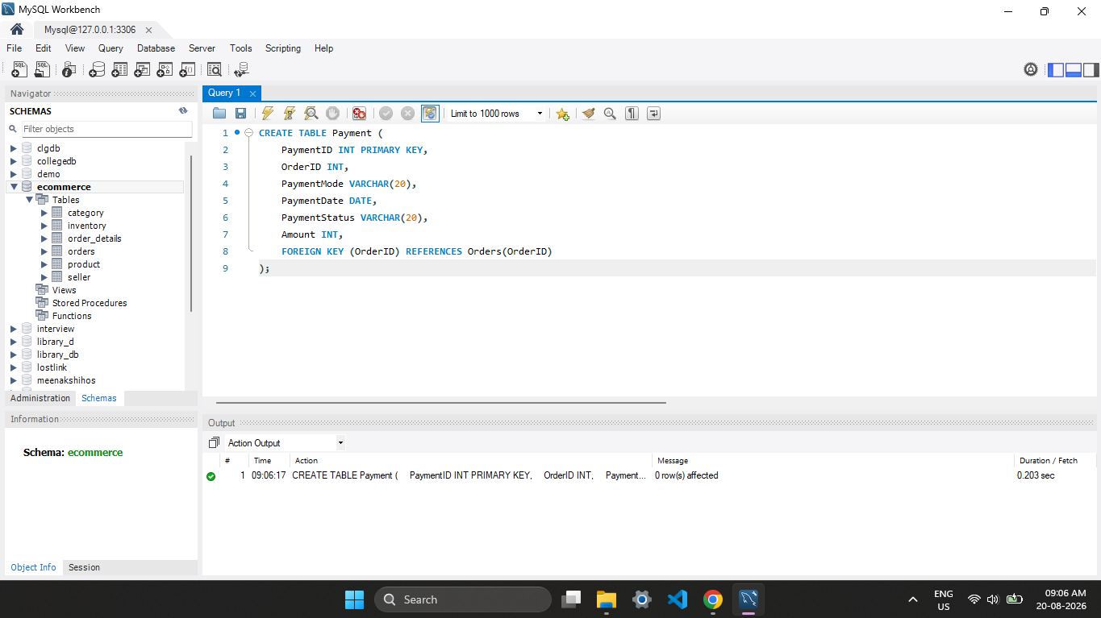

2. Insert Payment Details
INSERT INTO Payment VALUES
(1, 1, 'UPI', '2026-08-14', 'Success', 50000),
(2, 2, 'Card', '2026-08-14', 'Success', 20800),
(3, 3, 'Cash', '2026-08-14', 'Failed', 1600);

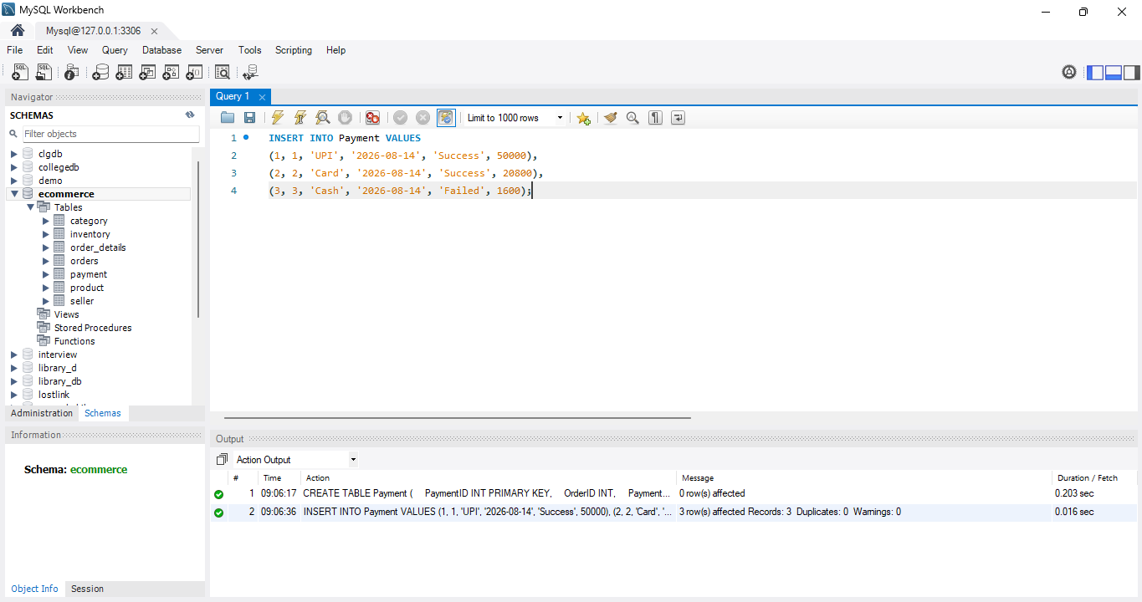

3. Display Payments
SELECT * FROM Payment;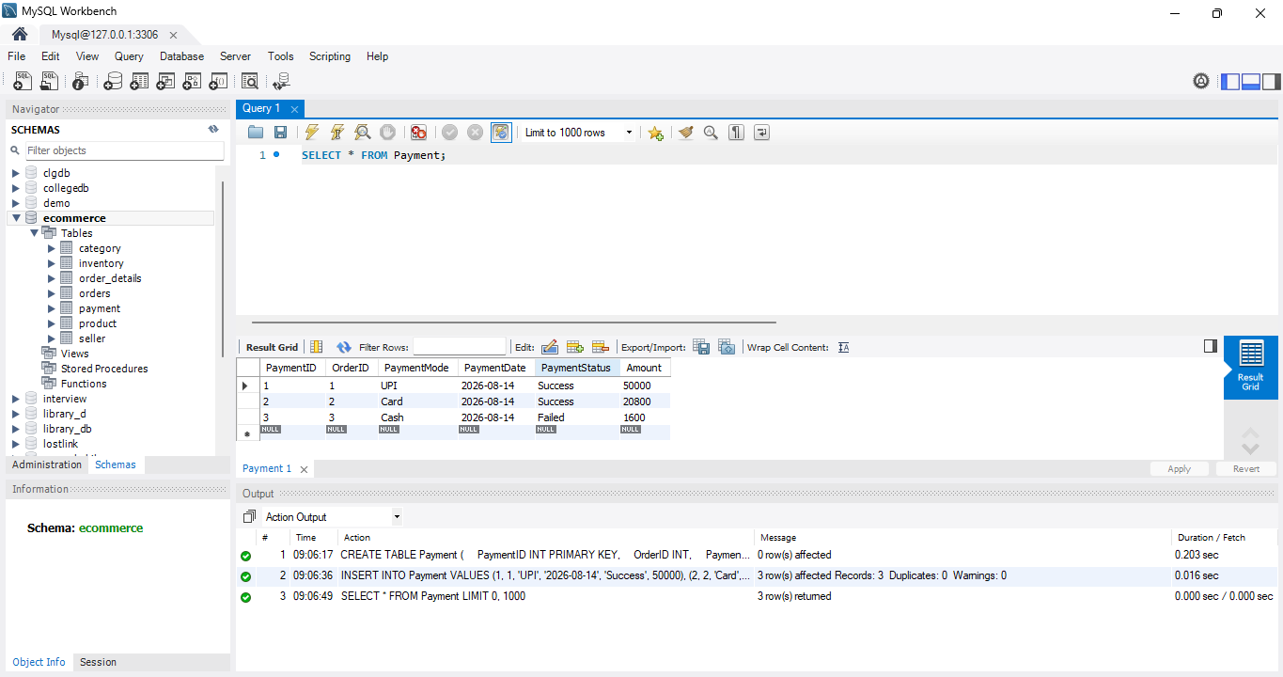
4. Update Payment Status
UPDATE Payment
SET PaymentStatus = 'Success'
WHERE PaymentID = 3;
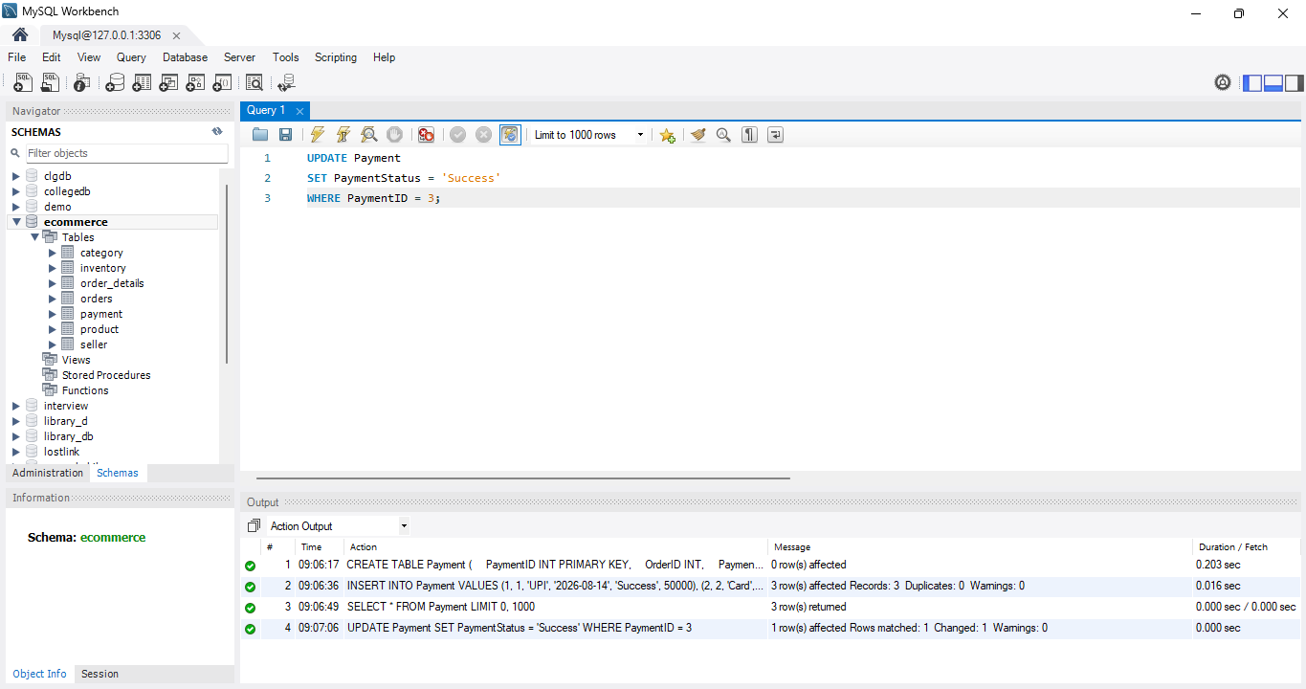
5. Show Successful Transactions
SELECT * FROM Payment
WHERE PaymentStatus = 'Success';
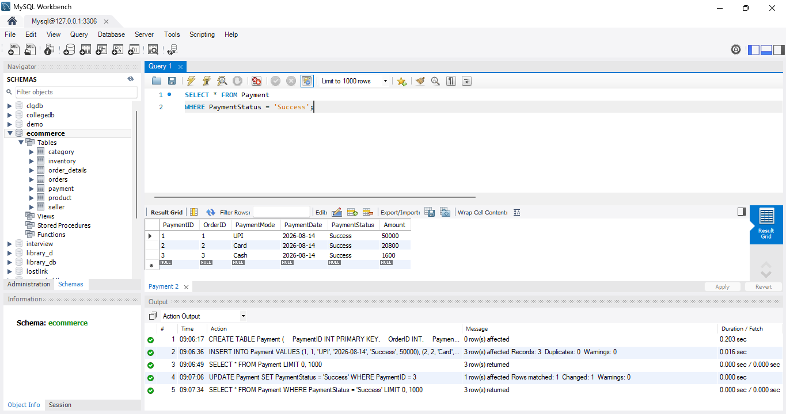
6. Show Failed Transactions
SELECT * FROM Payment
WHERE PaymentStatus = 'Failed';
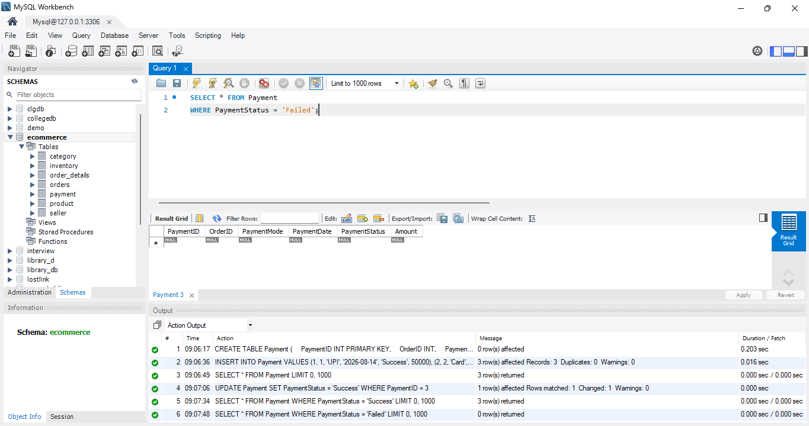

7. Analyze Payment Methods
SELECT PaymentMode, COUNT(*) AS Total
FROM Payment
GROUP BY PaymentMode;

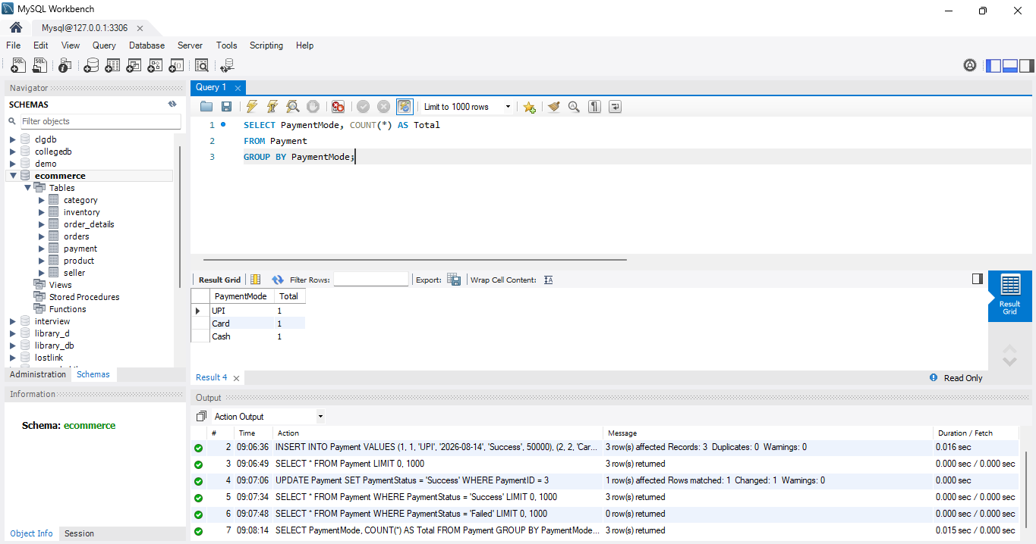

8. Payment Transaction Report
SELECT
Payment.PaymentID,
Orders.CustomerName,
Payment.PaymentMode,
Payment.PaymentDate,
Payment.Amount,
Payment.PaymentStatus
FROM Payment
JOIN Orders
ON Payment.OrderID = Orders.OrderID;
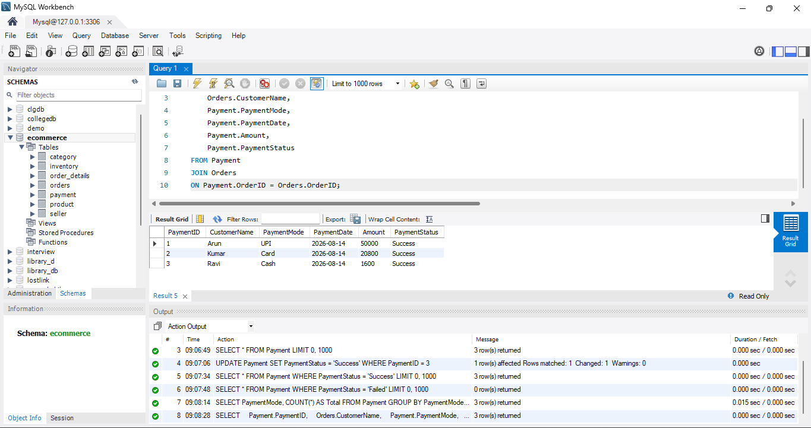

9. Total Successful Payment Amount
SELECT SUM(Amount) AS TotalAmount
FROM Payment
WHERE PaymentStatus = 'Success';
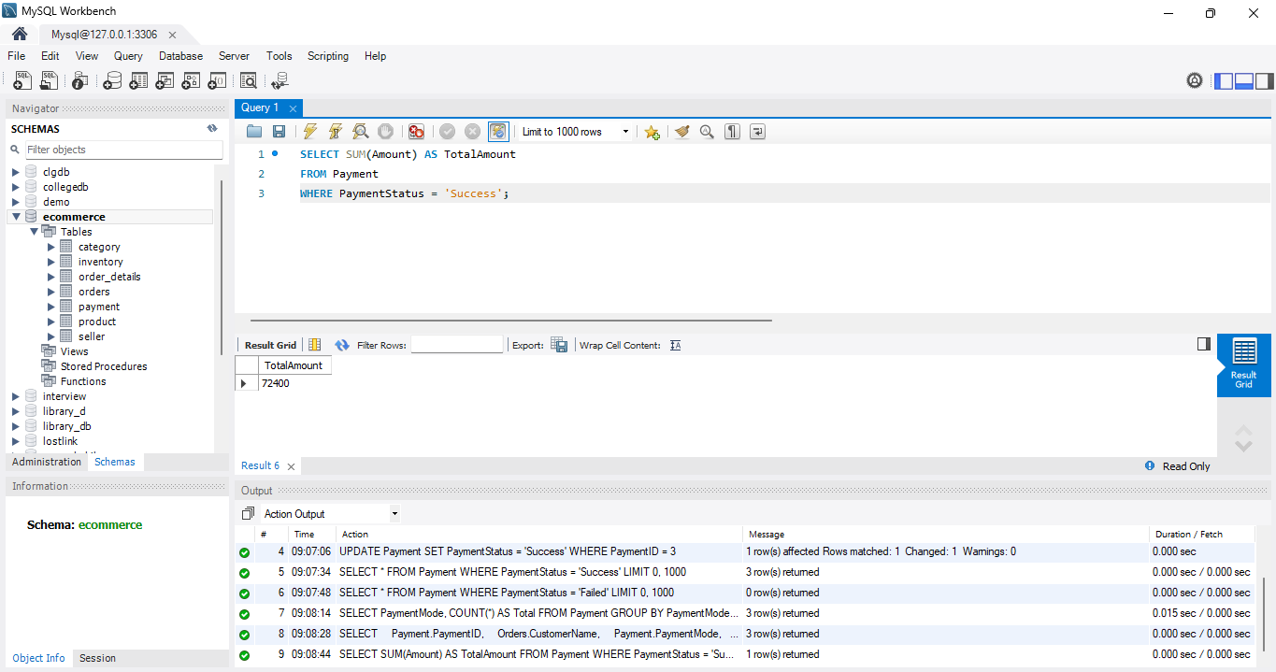

S

